Native American Studies
Presents

Dr. Robin Gray (Ts’msyen/Cree)
UC President’s Postdoctoral Fellow
Department of History, UC Santa Cruz

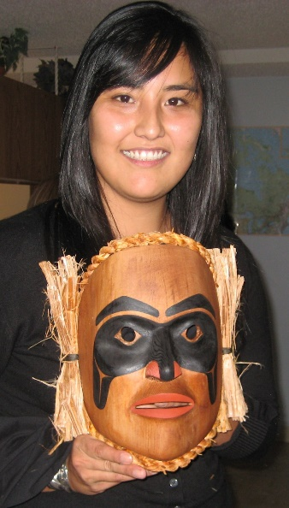

Friday, November 3, 2017
3:30-5:00PM
David Risling Room (3201 Hart)

“The Reach of Indigenous Dispossession: Archives and the Settler Colonial Project”

Settler colonialism relies on the dispossession of Indigenous lands, but it becomes justified through the production of ideas about Indigeneity, and the codification of imposed property regimes. In studying the reach of Indigenous dispossession, the archive becomes a critical site of analysis where Indigenous knowledge and cultural expressions are classified and circulated, and property logics are administered and naturalized. In this talk, Dr. Gray will discuss the efforts of Ts’msyen from Lax Kw’alaams, BC, Canada to repatriate a collection of sound recordings from the Laura Boulton Collection of Traditional and Liturgical Music to expose the colonizing properties of intellectual property law as it intersects with archival preservation practices.

