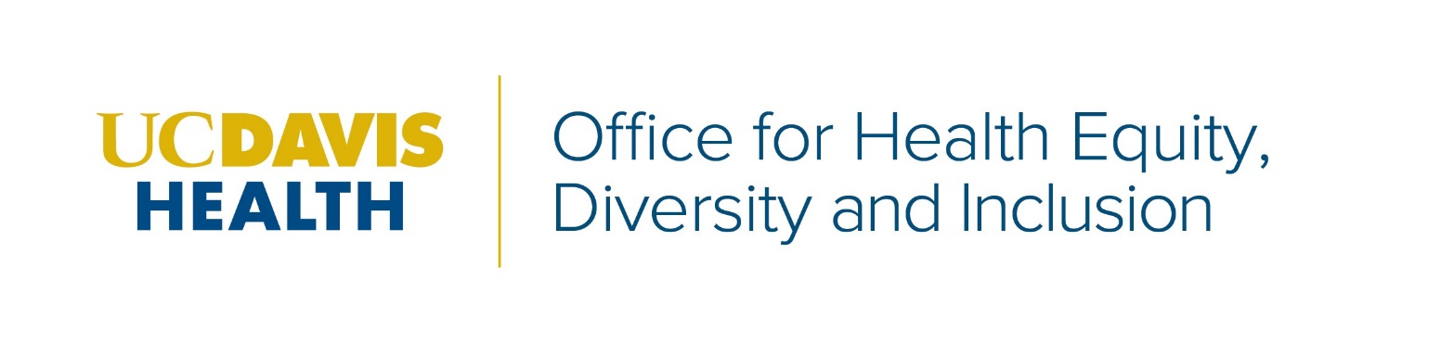
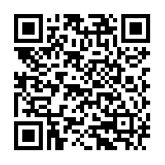

Register Now!! of

Principles of Community Week
February 22-26

RSVP HERE
or use the QR code below to register for the Principles of Community Virtual
Pop Up you are interested in attending.

Principles of Community Virtual Pop Ups!
- Select a Pop Up
- Register
- Attend
You may register for one or more event by
using the link or
QR code above.

Principles of Community 2021
Monday, February 22
Opening Day Ceremony – 11:30am -12:30pm

Employee Resource Group Fair – 1pm-2pm

Tuesday, February 23
Trivia Fun: Diversity Jeopardy – 1pm-2pm
Patient Care Services/Diversity, Equity & Inclusion Council
Virtual Community Mixer – 1pm–2pm

Inclusion Starts with “I” – 2pm-3pm

Wednesday, February 24
Ask Me Anything: LGBTQ+ – 12pm-1pm

DiversABILITY in a Virtual World – 1pm-2pm

Discussion - Cultural Humility:
Attending to Our Connections – 1pm–2pm

Words Matter: Diversity Language 101 – 2pm-3pm

Documentary Film Screening: Power to Heal – 4pm-5:30pm

Documentary Film Screening: Dolores Huerta – 4pm-5:30pm

Thursday, February 25
Small and Diverse Supplier Expo – 10am-2pm

Healing Circles: Building Caring Communities -12pm-1pm

Food and Community with Chef Taro Arai - 12pm-1pm

Patient Care Services/Diversity, Equity & Inclusion Council Virtual Community Mixer – 1pm-2pm

Clinical Translational Science Center and Alzheimer’s Disease Research Center - Vietnamese Mini Medical School
Session One: 2-2:15pm
Session Two: 2:45-3pm

Friday, February 26
Growing as a Community: Leadership in Action Panel – 12pm-1pm
Discussion - Cultural Humility: Resisting Fear and Failure on Cross-Cultural Encounters –1pm-2pm

